Requirement Document
Context Diagram

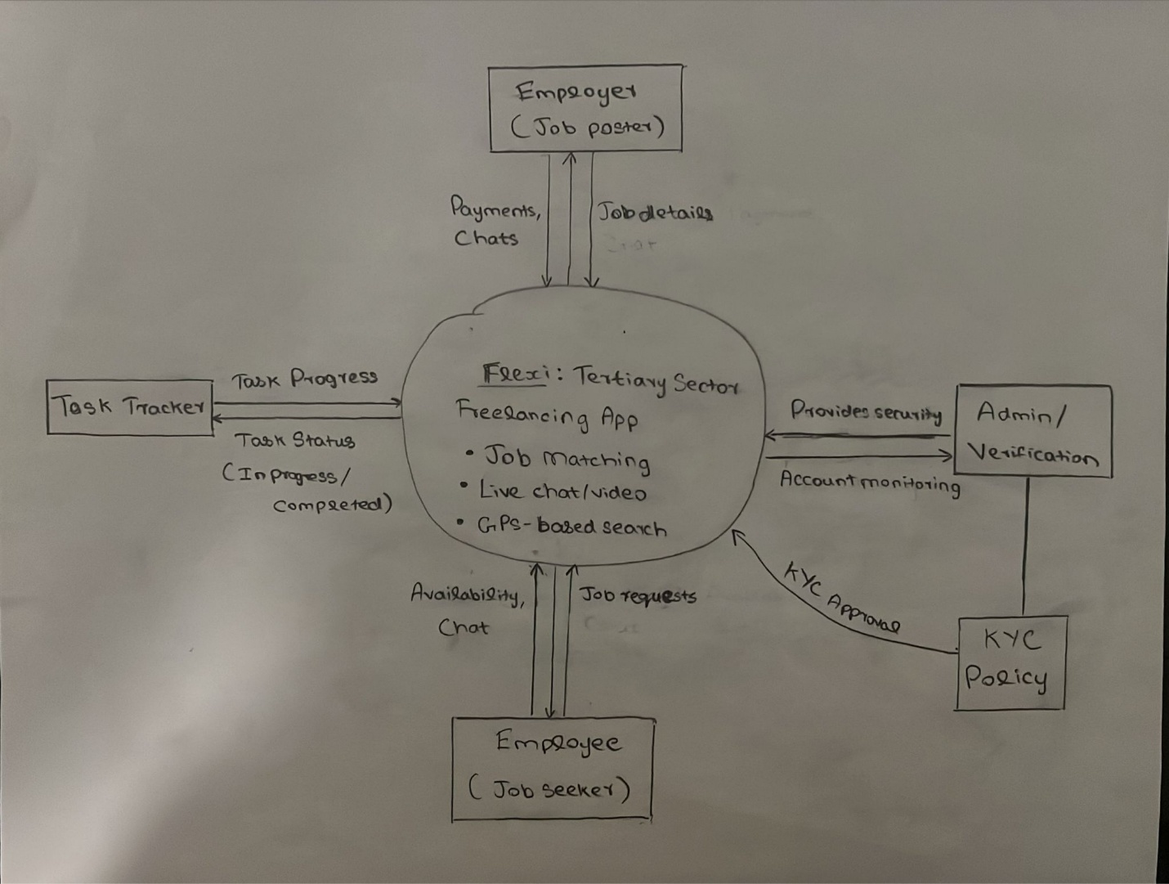

Functional requirements - describe what the software does
Display wanted tasks
Allow users to upload tasks
Allow users to select candidates
Allow user to apply for tasks
Allows user to track tasks status
Display profile page

